SOFTWARE REQUIREMENTS SPECIFICATION (SRS)
Automation Exercise
Web Automation Testing Project

Prepared By:
Basil Samouh
Ahmad AlGul
Hamza Belal
Mohammed AlSwesy

Contents

1. Introduction 3
2. Project Scope 3
3. Application Overview 4
4. Actors 4
5. Business Requirements 4
6. Functional Requirements 5
7. Non-Functional Requirements 5
8. Selected Workflows 6
Workflow 1 — User Authentication 6
Workflow 2 — Shopping Cart & Checkout 6
9. Out of Scope 6
10. Assumptions 6

1. Introduction

The purpose of this document is to define the software requirements for testing the Automation Exercise web application. This project focuses on performing both manual and automation testing for selected workflows using Selenium WebDriver with Java and TestNG framework.
The project aims to validate the functionality, usability, and reliability of the selected workflows within the application.

2. Project Scope

This project covers testing two major workflows in the Automation Exercise website:
- User Authentication Workflow
- User Registration
- Login with valid credentials
- Login with invalid credentials
- Logout functionality
- Shopping Cart & Checkout Workflow
- Browse products
- Search for products
- Add products to cart
- View cart
- Proceed to checkout
- Verify checkout process

The project includes:
- SRS documentation
- Test Plan
- Test Cases
- Traceability Matrix
- Selenium Automation Scripts
- TestNG Reports

3. Application Overview

Automation Exercise is a demo e-commerce web application designed for software testing practice. The website allows users to create accounts, log in, browse products, manage shopping carts, and complete checkout operations.
The application is widely used for practicing:
- Manual Testing
- Automation Testing
- Selenium WebDriver
- TestNG Framework
- End-to-End Testing workflows
Website URL: https://automationexercise.com/

4. Actors

Actor | Description
Guest User | A user who visits the website without logging in
Registered User | A user who has an account and can log in to the system

5. Business Requirements

ID | Requirement
BR-01 | The system shall allow users to register a new account successfully.
BR-02 | The system shall allow registered users to log in using valid credentials.
BR-03 | The system shall prevent users from logging in with invalid credentials.
BR-04 | The system shall allow users to browse available products.
BR-05 | The system shall allow users to search for products.
BR-06 | The system shall allow users to add products to the shopping cart.
BR-07 | The system shall allow users to proceed to checkout.
BR-08 | The system shall display order confirmation after successful checkout.
BR-09 | The system shall allow users to log out successfully.

6. Functional Requirements
ID | Functional Requirement
FR-01 | User can open the home page successfully.
FR-02 | User can navigate to the Signup/Login page.
FR-03 | User can register using valid account information.
FR-04 | User can log in with valid email and password.
FR-05 | System displays an error message for invalid login attempts.
FR-06 | User can log out from the application.
FR-07 | User can navigate to the products page.
FR-08 | User can search for products using the search bar.
FR-09 | User can add products to the cart.
FR-10 | User can view selected products in the cart page.
FR-11 | User can proceed to checkout successfully.
FR-12 | System displays order confirmation after checkout completion.

7. Non-Functional Requirements
ID | Requirement
NFR-01 | The application should load pages within acceptable response time.
NFR-02 | The system should display clear validation and error messages.
NFR-03 | The application should be compatible with Google Chrome browser.
NFR-04 | The user interface should be simple and easy to use.
NFR-05 | The system should maintain stable behavior during test execution.
NFR-06 | The automation scripts should follow Page Object Model (POM) design pattern.
NFR-07 | The automation framework should use TestNG for test execution and reporting.

8. Selected Workflows

Workflow 1 — User Authentication
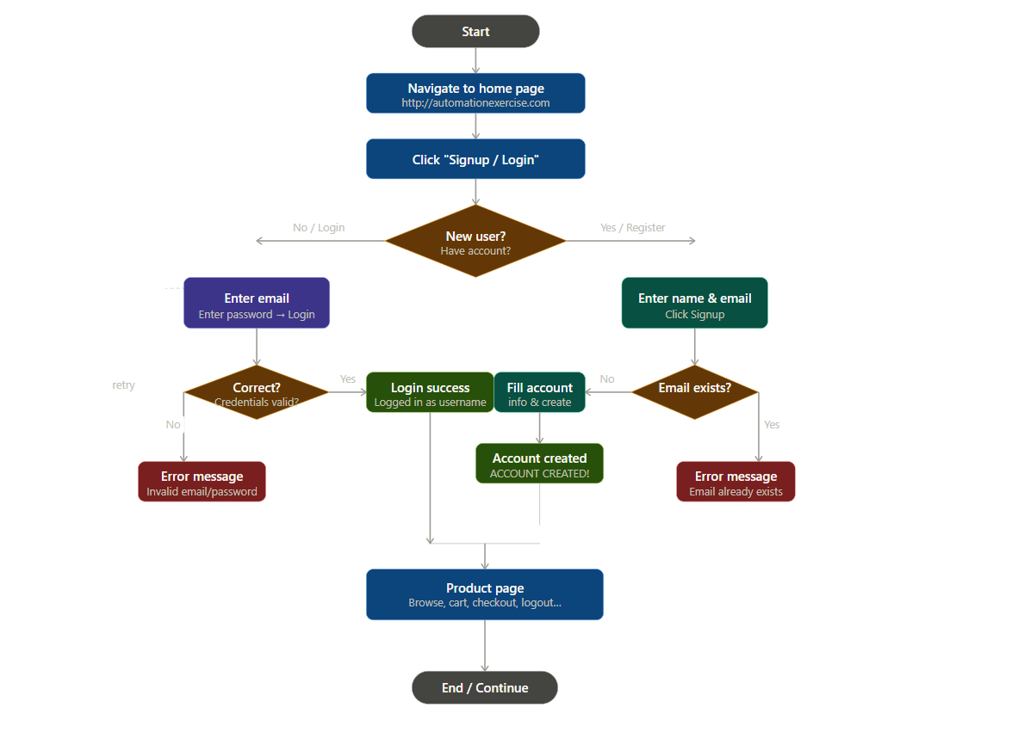

Workflow 2 — Shopping Cart & Checkout
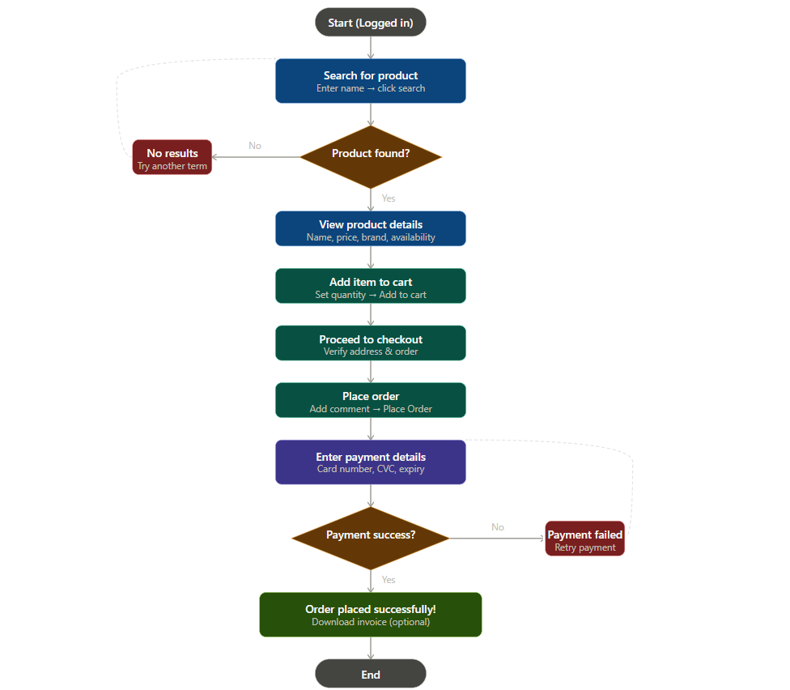

9. Out of Scope
The following items are:
- Performance Testing
- Security Testing
- Mobile Application Testing
- Database Testing
- Payment Gateway Real Transactions
- API Testing
- Cross-browser testing except Google Chrome

10. Assumptions
- The website is available and accessible during testing.
- Test data and user accounts are available when needed.
- Internet connection is stable during automation execution.
- Google Chrome browser is installed on the testing environment.
- Selenium WebDriver and TestNG dependencies are configured correctly.

